Acknowledgment of Understanding

I, Logan Schraeder have read and fully understood the syllabus for CS 898AW Spring 2025. I agree to adhere to the guidelines and requirements as outlined.

Signature: ______________________

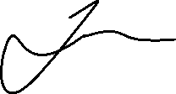

Date: 22 January 2025